
Christ Church
Episcopal
Serving God’s People for over 150 years

524 N. 5th Street, Beatrice, NE 68310
402 223-5515 christchurchbaptism@gmail.com
Website: christchurchbeatrice.com on Facebook
Services Streamed: youtube.com/@christbhurchepiscopalbeatr654

Welcome to Christ Church! If you are a visitor, please fill out a visitor card and place it in the offering plate or give it to a Greeter. All Baptized persons are welcome to receive communion at the Lord’s Table. The words for the liturgy are in the bulletin or the red Book of Common Prayer (BCP). The hymns and service music (S) are in The Hymnal.

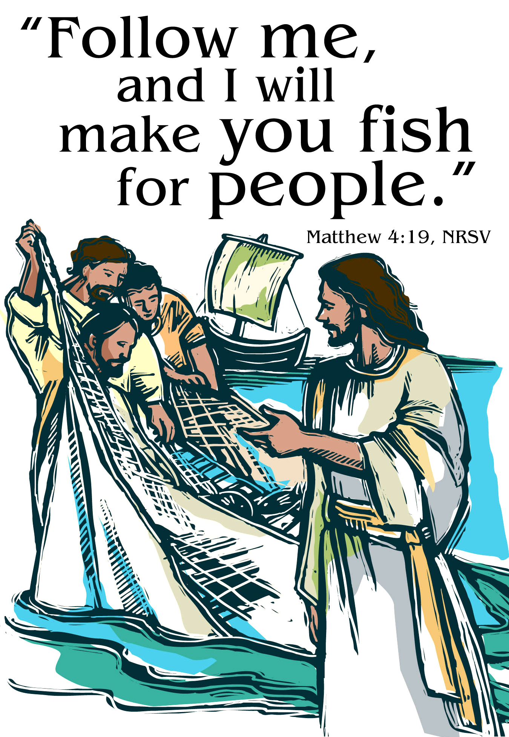
Third Sunday after Epiphany
Holy Eucharist, Rite II
January 25, 2026

The Holy Eucharist: Rite Two
Prelude

Welcome

The Word of God BCP 355
The people standing, the Celebrant says
Blessed be God: Father, Son, and Holy Spirit.
People And blessed be his kingdom, now and for ever.
Amen.

Collect for Purity
Celebrant says
Give us grace, O Lord, to answer readily the call of our
Savior Jesus Christ and proclaim to all people the Good
News of his salvation, that we and all the whole world may
perceive the glory of his marvelous works; who liveth and
reigneth with thee and the Holy Spirit, one God, for ever and
ever. Amen.

Gloria in Excelsis BCP 356

Glory to God in the highest,
and peace to his people on earth.
Lord God, heavenly King,
almighty God and Father,
we worship you, we give you thanks,
we praise you for your glory.
Lord Jesus Christ, only Son of the Father,
Lord God, Lamb of God,
you take away the sin of the world:
have mercy on us;
you are seated at the right hand of the Father:
receive our prayer.
For you alone are the Holy One,
you alone are the Lord,
you alone are the Most High,
Jesus Christ,
with the Holy Spirit,
in the glory of God the Father. Amen.

Collect of the Day BCP 357
The Celebrant says to the people:
The Lord be with you.
People And also with you.
Celebrant Let us pray.

Contemporary Collect (found in the Insert) Read in Unison

Be seated for the reading of the Lessons:
Lessons: (found in the Insert)
First Reading: Isaiah 9:1-4
The Reader says: The Word of the Lord.
People respond: Thanks be to God.

Psalm: 27:1, 5-13

Second Reading: 1 Corinthians 1:10-18
The Reader says: The Word of the Lord.
People respond: Thanks be to God.

Then, all standing, the Celebrant says
The Holy Gospel of our Lord Jesus Christ
according to Matthew.
People Glory to you, Lord Christ.

Gospel: Matthew 4:12-23
When Jesus heard that John had been arrested, he withdrew to Galilee. He left Nazareth and made his home in Capernaum by the sea, in the territory of Zebulun and Naphtali, so that what had been spoken through the prophet Isaiah might be fulfilled:
“Land of Zebulun, land of Naphtali,
on the road by the sea, across the Jordan, Galilee of the Gentiles—
the people who sat in darkness
have seen a great light,
and for those who sat in the region and shadow of death
light has dawned.”
From that time Jesus began to proclaim, “Repent, for the kingdom of heaven has come near.”
As he walked by the Sea of Galilee, he saw two brothers, Simon, who is called Peter, and Andrew his brother, casting a net into the sea—for they were fishermen. And he said to them, “Follow me, and I will make you fish for people.” Immediately they left their nets and followed him. As he went from there, he saw two other brothers, James son of Zebedee and his brother John, in the boat with their father Zebedee, mending their nets, and he called them. Immediately they left the boat and their father, and followed him.
Jesus went throughout Galilee, teaching in their synagogues and proclaiming the good news of the kingdom and curing every disease and every sickness among the people.
After the Gospel, the Celebrant says
The Gospel of the Lord.
People Praise to you, Lord Christ.

Homily The Rev. Sarah Shofstall

All standing, said in unison
Nicene Creed BCP 358-359
We believe in one God,
the Father, the Almighty,
maker of heaven and earth,
of all that is, seen and unseen.
We believe in one Lord, Jesus Christ,
the only Son of God,
eternally begotten of the Father,
God from God, Light from Light,
true God from true God,
begotten, not made,
of one Being with the Father.
Through him all things were made.
For us and for our salvation
he came down from heaven:
by the power of the Holy Spirit
he became incarnate from the Virgin Mary,
and was made man.
For our sake he was crucified under Pontius Pilate;
he suffered death and was buried.
On the third day he rose again
in accordance with the Scriptures;
he ascended into heaven
and is seated at the right hand of the Father.
He will come again in glory to judge the living and the dead,
and his kingdom will have no end.
We believe in the Holy Spirit, the Lord, the giver of life,
who proceeds from the Father and the Son.
With the Father and the Son he is worshiped and glorified.
He has spoken through the Prophets.
We believe in one holy catholic and apostolic Church.
We acknowledge one baptism for the forgiveness of sins.
We look for the resurrection of the dead,
and the life of the world to come. Amen.

Prayers of the People: BCP 388 – Form 4
The Leader and People pray responsively

Let us pray for the Church and for the world.
Grant, Almighty God, that all who confess your Name may
be united in your truth, live together in your love, and reveal
your glory in the world.
Silence
Lord, in your mercy
Hear our prayer.

Guide the people of this land, and of all the nations, in the
ways of justice and peace; that we may honor one another
and serve the common good.
Silence
Lord, in your mercy
Hear our prayer.
Give us all a reverence for the earth as your own creation,
that we may use its resources rightly in the service of others
and to your honor and glory.
Silence
Lord, in your mercy
Hear our prayer.
Bless all whose lives are closely linked with ours, and grant
that we may serve Christ in them, and love one another as he
loves us.
Silence
Lord, in your mercy
Hear our prayer.
Comfort and heal all those who suffer in body, mind, or
spirit; give them courage and hope in their troubles, and
bring them the joy of your salvation.
Silence
Lord, in your mercy
Hear our prayer.
We commend to your mercy all who have died, that your will
for them may be fulfilled; and we pray that we may share
with all your saints in your eternal kingdom.
Silence
Lord, in your mercy
Hear our prayer.
Let us pray for our own needs and those of others.
Let us pray for the ministry of the Right Rev. Sean Rowe; Bishop Scott Barker; Mother Sarah; Deacon Frank; Our Diocesan Staff and the Work of the Diocese Bishop J. Scott Barker, Canon Elizabeth Easton, Br. James Dowd, Beth Byrne, Lachisha Baskin, Megan Griffiths, The Rev. Archdeacon Roy Phillips St. Martin of Tours, Omaha The Rev. Kim Roberts, The Rev. Deacon Mark Kowalski; Dioceses and people of South Sudan and the Dominican Republic; For the people of Haiti, all refugees, and victims of violence; For our nation, our state of Nebraska, and victims of natural disasters around the world. We also pray for the mission of The Episcopal Church and the Nebraska Episcopal Parishes in transition.
EM: Lord in your Mercy C: Hear our Prayer

Let us pray this week for: Rosemary Nelson, Lynn Weaver, Dave & Mickey Gleason, Dale Perkins, Kristen Klaus, Karina, Glenn Heideman, Crystal Alvarez, Amanda, Rick, Wade Johnson, Roy Schwisow, Kai Spann, Rose-Ann Parde, Jenny, Keith, Jennifer Cohorst, Suzi Buss, Tom Turbiville, Sam & Pam Dierberger, Larry Vetrovsky, Howard Denton, Hope, Tim Sedlacek, Phil Kohrs, Tom, Jan, Kate, Monique Grotian, Maggie Boyce, Charlot Williams, Terry Johnsen, Andy Tilman, & John & Kathy Williams
EM: Lord in your Mercy C: Hear our Prayer

In Thanksgiving we pray for any Birthdays and any Anniversaries.
EM: Lord in your Mercy C: Hear our Prayer

Confession of Sin & Absolution
Celebrant says
Let us confess our sins against God and our neighbor.
Silence may be kept.
The people stand or kneel. Minister and People say in unison
Most merciful God,
we confess that we have sinned against you
in thought, word, and deed,
by what we have done,
and by what we have left undone.
We have not loved you with our whole heart;
we have not loved our neighbors as ourselves.
We are truly sorry and we humbly repent.
For the sake of your Son Jesus Christ,
have mercy on us and forgive us;
that we may delight in your will,
and walk in your ways,
to the glory of your Name. Amen.

The Celebrant stands and says:
Almighty God have mercy on you, forgive you all your sins
through our Lord Jesus Christ, strengthen you in all
goodness, and by the power of the Holy Spirit keep you in
eternal life. Amen.

The Peace BCP 360
All stand. The Celebrant says to the people
The peace of the Lord be always with you.
People And also with you.

Announcements
Holy Communion
The Celebrant says
Offertory Sentence
The Great Thanksgiving
Eucharistic Prayer B BCP 367

The people remain standing. The Celebrant faces them and says
The Lord be with you.
People And also with you.
Celebrant Lift up your hearts.
People We lift them to the Lord.
Celebrant Let us give thanks to the Lord our God.
People It is right to give him thanks and praise.

Then, facing the Holy Table, the Celebrant proceeds
It is right, and a good and joyful thing, always and every-
where to give thanks to you, Father Almighty, Creator of
heaven and earth.

For by water and the Holy Spirit you have made us a new
people in Jesus Christ our Lord, to show forth your glory in
all the world.

Therefore we praise you, joining our voices with Angels and
Archangels and with all the company of heaven, who for ever sing this hymn to proclaim the glory of your Name:

Celebrant and People
Sanctus BCP 362

Holy, Holy, Holy Lord, God of power and might,
heaven and earth are full of your glory.
Hosanna in the highest. Hosanna in the highest.
Blessed is he who comes in the name of the Lord.
Hosanna in the highest.

The people stand or kneel. Then the Celebrant continues
We give thanks to you, O God, for the goodness and love
which you have made known to us in creation; in the calling
of Israel to be your people; in your Word spoken through the
prophets; and above all in the Word made flesh, Jesus, your
Son. For in these last days you sent him to be incarnate from
the Virgin Mary, to be the Savior and Redeemer of the world.
In him, you have delivered us from evil, and made us worthy
to stand before you. In him, you have brought us out of error
into truth, out of sin into righteousness, out of death into life.

On the night before he died for us, our Lord Jesus Christ took
bread; and when he had given thanks to you, he broke it, and
gave it to his disciples, and said, "Take, eat: This is my Body,
which is given for you. Do this for the remembrance of me."

After supper he took the cup of wine; and when he had given
thanks, he gave it to them, and said, "Drink this, all of you:
This is my Blood of the new Covenant, which is shed for you
and for many for the forgiveness of sins. Whenever you drink
it, do this for the remembrance of me."

Therefore, according to his command, O Father,

Celebrant and People
We remember his death,
We proclaim his resurrection,
We await his coming in glory;

And we offer our sacrifice of praise and thanksgiving to you,
O Lord of all; presenting to you, from your creation, this
bread and this wine.

We pray you, gracious God, to send your Holy Spirit upon
these gifts that they may be the Sacrament of the Body of
Christ and his Blood of the new Covenant. Unite us to your
Son in his sacrifice, that we may be acceptable through him,
being sanctified by the Holy Spirit. In the fullness of time,
put all things in subjection under your Christ, and bring us to
that heavenly country where, with [ and] all your saints, we may enter the everlasting heritage of your sons and daughters; through Jesus Christ our Lord, the firstborn of all creation, the head of the Church, and the author of our salvation.
By him, and with him, and in him, in the unity of the Holy
Spirit all honor and glory is yours, Almighty Father, now and
for ever. AMEN.

Celebrant And now, as our Savior Christ has taught us,
we are bold to say,
The Lord’s Prayer BCP 364

The Breaking of the Bread BCP 364

The Celebrant breaks the consecrated Bread.
[Alleluia.] Christ our Passover is sacrificed for us;
People Therefore let us keep the feast. [Alleluia.]

Reception of Communion
All Baptized persons are welcome to receive communion at the Lord’s Table
Communion Music

Post Communion Prayer BCP 365
The people stand or kneel. Minister and People say in unison
Eternal God, heavenly Father, you have graciously accepted us as living members of your Son our Savior Jesus Christ, and you have fed us with spiritual food in the Sacrament of his Body and Blood. Send us now into the world in peace, and grant us strength and courage to love and serve you with gladness and singleness of heart; through Christ our Lord. Amen.

The Celebrant says
Blessing

The people standing,

Dismissal BCP 366
Celebrant Let us go forth in the name of Christ.
People Thanks be to God. Alleluia, Alleluia.

Postlude

Please join us for Coffee Hour in the Parish Hall after the service.

Mother Sarah can be reached by phone at (413)531-9023
or by Email @ sarahshofstall@gmail.com



Mark your calendars

Annual Meeting - February 1, 2026 (after church) with a meal provided by Evening Guild.

Contact Carolyn Hovendick for bulletin items by Wednesday of each week; 402-806-1613 or christchurchbaptism@gmail.com.

Please notify Judy Knispel to have prayer requests added or removed from the bulletin. Thanks for your assistance in keeping this list updated and for all the prayers for our family and friends.

Upcoming Worship & Events
Sun Feb 1 Holy Eucharist @ 10:00 Discretionary Fund Offering
Annual Mtg to follow the service with a meal provided
Sun Feb 8 Holy Eucharist @ 10:00
Sun Feb 15 Morning Prayer @ 10:00
This Week:
Tues Jan 27 Warren’s Community Dinner Table
______________________________________________________________________________

Worship leaders Today: The Rev. Sarah Shofstall; EM: Steve Hovendick; Lector: Steve Hovendick; Video Tech: Rich Hovendick; Greeters: Steph Perkins; Coffee Hour: Scott & Phyllis; Altar Guild: Tina

Worship leaders for Feb 1: The Rev. Sarah Shofstall; EM: Rich Hovendick; Lector: Rich Hovendick; Video Tech: Barb Brenden; Greeters: Scott & Phyllis Johnson; Altar Guild: Linda & Elaine

Church Leaders: Church Leaders: The Rev. Sarah Shofstall, The Rev. Frank Smith, Deacon; Sr. Warden: Steph Perkins; Jr. Warden: Barb Brenden; Vestry: Linda Hovendick, Jonni Jones, Judy Knispel, Organist: TBA; Altar Guild: Linda Hovendick; Treasurer: Scott Knispel; Christian Ed:

